MERN PRACTICAL
PRACTICAL NO 1
Set up a MERN stack development environment by creating a React frontend application and Node.js + Express backend server.
- Step 1: Create Project Folder and inside it create two subfolders
MERN_Project
│
├── Frontend
└── Backend
- Step 2: Frontend Setup
Open frontend folder in terminal
Run : npm create vite@latest my-app -- --template react
- Step 3: Move into React Project Folder
- cd my-app
- Step 4: npm install
- Step 5: npm run dev
- Step 6: Backend Setup
- Step 7: npm init -y
- Step 8: npm install express
- Step 9: npm install cors dotenv mongoose
- Step 10: npm install nodemon --save--dev

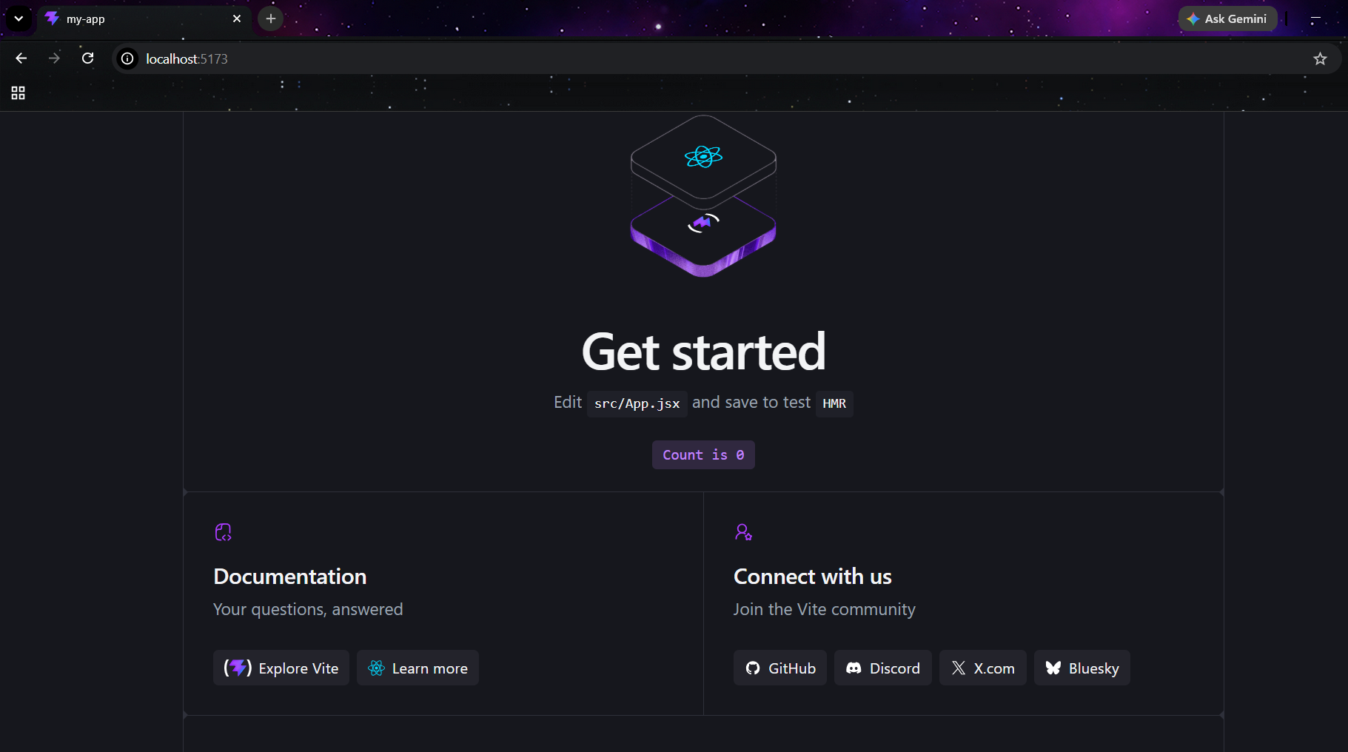

PRACTICAL NO 2
Develop a simple REST API using Express.js and connect the React frontend to fetch and display data using Axios or Fetch API.
Server.js
const express = require("express");
const cors = require("cors");

const app = express();
app.use(cors());

const students = [
{ id:1, name:"Rahul", course : "BSc IT" },
{ id:2, name:"Priya", course : "BSc DS" },
{ id:3, name:"Ankit", course : "BCom" },
];

app.get("/students",(req, res)=> {
res.json(students);
});

const PORT = 5000;
app.listen(PORT, () => {
console.log(`Server is running on port ${PORT}`);
});

App.jsx
import React, { useState, useEffect } from "react";
import axios from "axios";

const App = () => {
const [students, setStudents] = useState([]);

useEffect(() => {
axios.get("http://localhost:5000/students")
.then(response => {
setStudents(response.data);
})
.catch(error => {
console.log(error);
});
}, []);

return (
<div>
<h1>Student Management System</h1>

<h2>Students List</h2>

<ul>
{students.map(student => (
<li key={student.id}>
{student.name} - {student.course}
</li>
))}
</ul>
</div>
);
};

export default App;
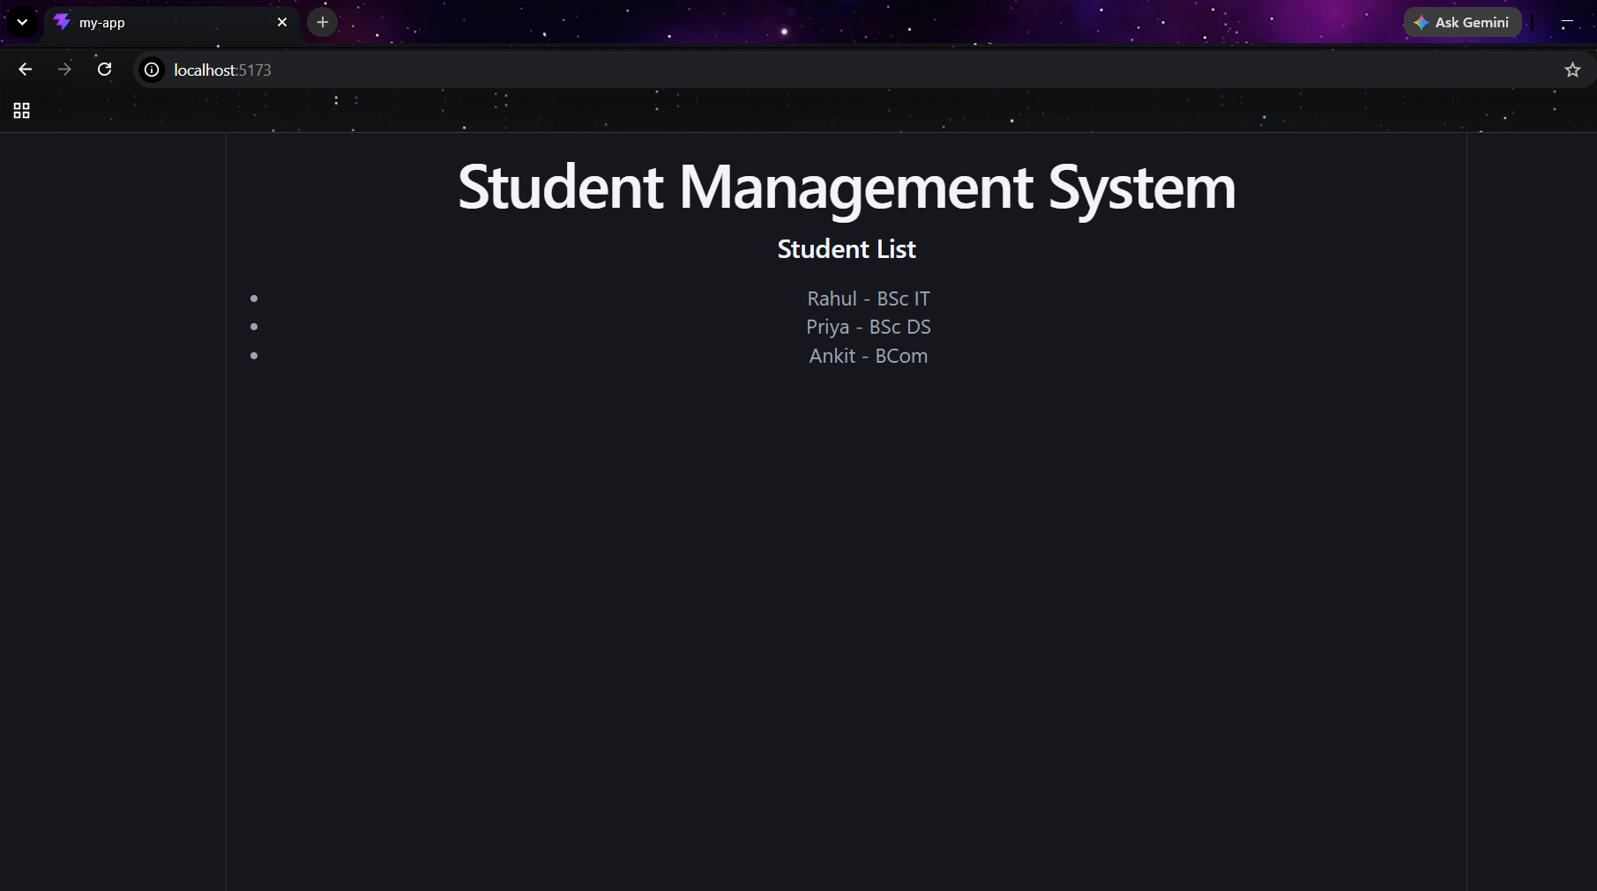

PRACTICAL NO 3
Create a basic MERN CRUD application implementing Create and Read operations using MongoDB and Mongoose.
Server.js
const express=require ("express");
const mongoose=require ("mongoose");
const cors=require ("cors");

const Student_Routes=require("./routes/Student_Routes.js");
const app=express();
app.use (cors());
app.use (express.json());
mongoose
.connect("mongodb://127.0.0.1:27017/studentDB")
.then(()=>console.log("MongoDB connected successfully"))
.catch(err=>console.log(err));
app.use("/student/",Student_Routes);
app.get("/",(req,res)=>{
res.send("Backend running Successfully");
});

app.listen(5000,()=>{
console.log("Server running on port 5000");
});

models/student.js
const mongoose=require("mongoose");

const studentSchema=new mongoose.Schema({
name:String,
roll:Number,
course:String
});
module.exports=mongoose.model("Student",studentSchema);

routes/Student_Routes.js
const express=require("express");
const router=express.Router();
const Student=require("../models/student");
router.post("/", async(req,res)=>
{
const student =new Student(req.body);
await student.save();
res.json(student);
});
router.get("/", async(req,res)=>{
const students =await Student.find();
res.json(students);
});
module.exports=router;
App.jsx
import React,{useState,useEffect} from 'react'
import axios from "axios"

const App = () => {

const [name,setName] = useState("")
const [roll,setRoll] = useState("")
const [course,setCourse] = useState("")
const [students,setStudents] = useState([])

useEffect(()=>{
fetchStudents()
},[])

const fetchStudents = async()=>{
const res = await axios.get("http://localhost:5000/student")
setStudents(res.data)
}

const addStudent = async()=>{
await axios.post("http://localhost:5000/student",{
name,
roll,
course
})
fetchStudents()
}

return (
<div>
<h2>Student Registration</h2>
<input placeholder='Name' onChange={(e)=>setName(e.target.value)} /> <br/>
<input placeholder='RollNo' onChange={(e)=>setRoll(e.target.value)} /><br/>
<input placeholder='Course' onChange={(e)=>setCourse(e.target.value)} /><br/>
<button onClick={addStudent}>Save</button>
<hr/><hr/>
<h2>Student List</h2>
{
students.map((s)=>{
return(
<div key={s.id}>
{s.name}-{s.roll}-{s.course}
</div>
)
})
}
</div>
)
}

export default App

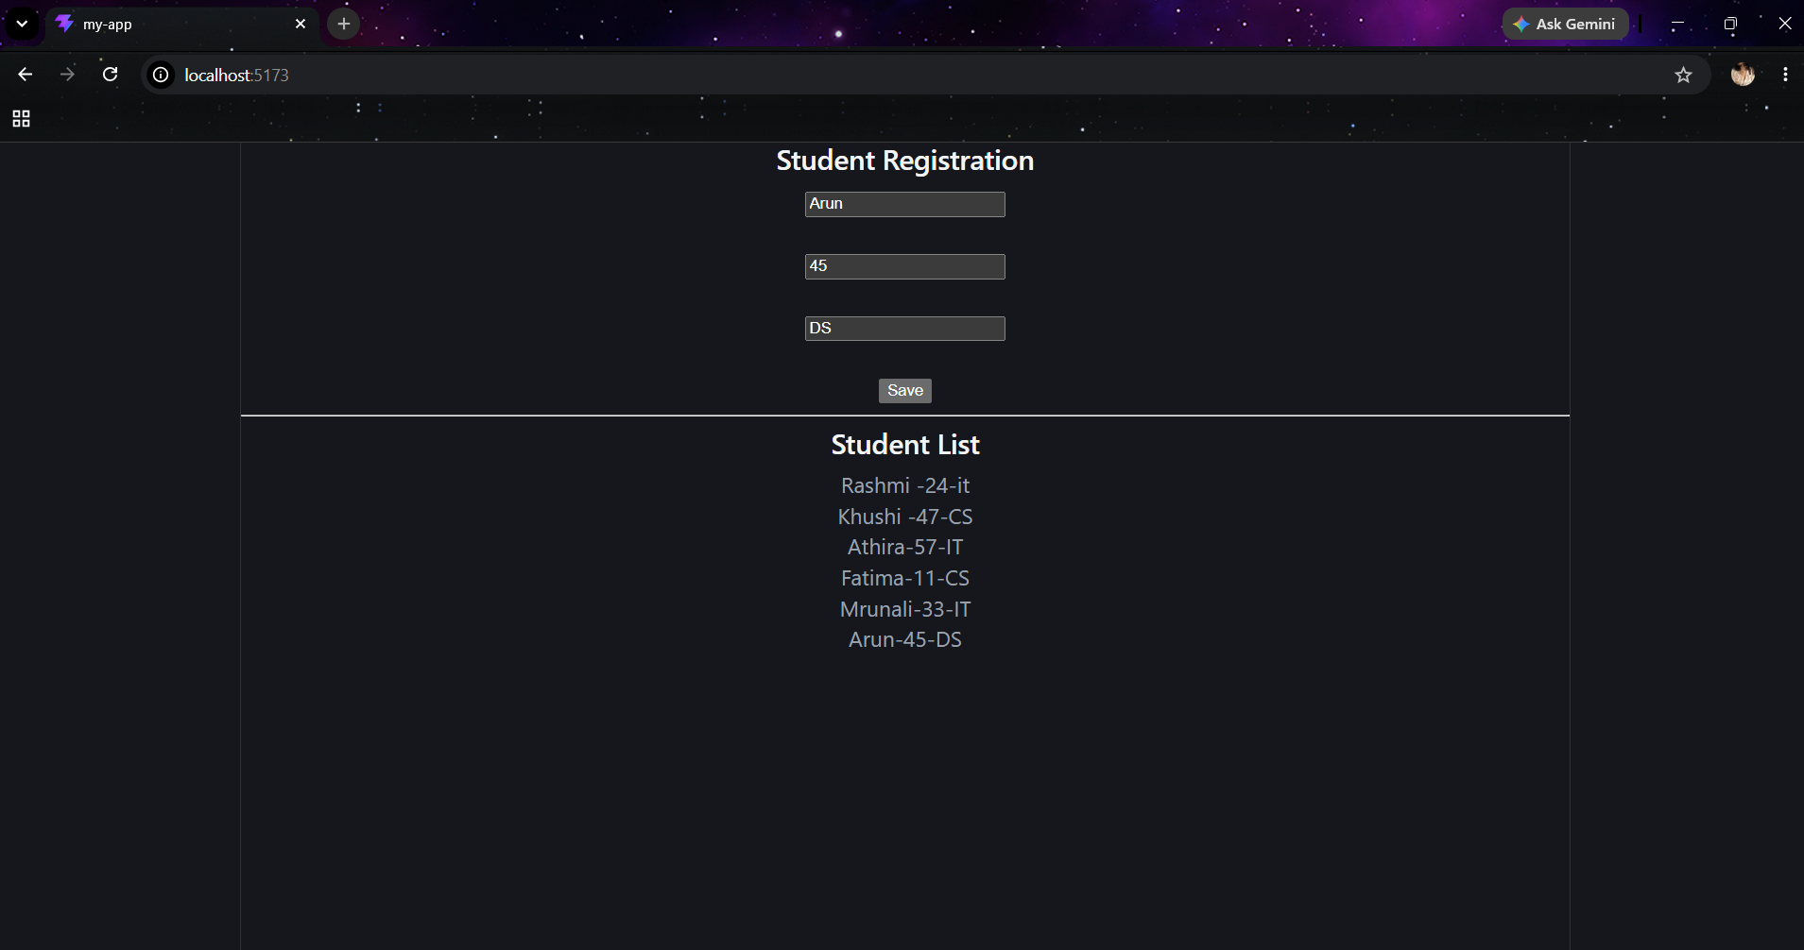
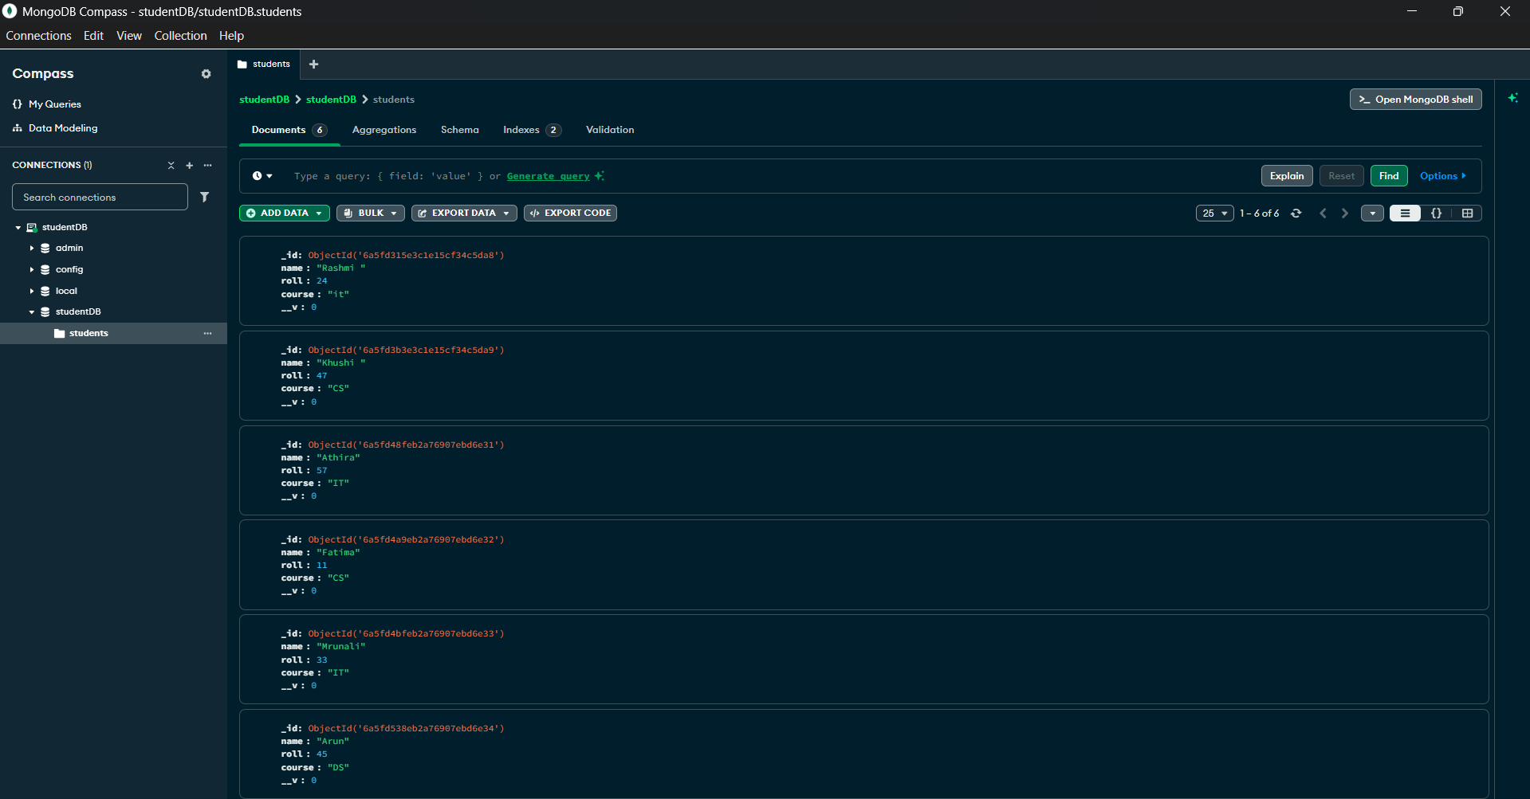

PRACTICAL NO 4
Extend the MERN CRUD application to support Upadate and Delete operations using with proper API endpoints.
(Student.js and StudentRoutes.js)same as above
Server.js
const express = require("express");
const mongoose = require("mongoose");
const cors = require("cors");

const Student = require("./models/student");
const Student_Routes = require("./routes/Student_Routes.js");

const app = express();

app.use(cors());
app.use(express.json());

mongoose
.connect("mongodb://127.0.0.1:27017/studentDB")
.then(() => console.log("MongoDB connected successfully"))
.catch(err => console.log(err));

app.use("/student/", Student_Routes);

app.get("/", (req, res) => {
res.send("Backend running Successfully");
});

app.put("/student/:id", async (req, res) => {
const updatedStudent = await Student.findByIdAndUpdate(
req.params.id,
req.body,
{ new: true }
);

res.json(updatedStudent);
});

app.delete("/student/:id", async (req, res) => {
const deletedStudent = await Student.findByIdAndDelete(
req.params.id
);

res.json(deletedStudent);
});

app.listen(5000, () => {
console.log("Server running on port 5000");
});

App.jsx
import React,{useState,useEffect} from 'react'
import axios from "axios"

const App = () => {

const [name,setName] = useState("")
const [roll,setRoll] = useState("")
const [course,setCourse] = useState("")
const [students,setStudents] = useState([])

const [editId,setEditId] = useState(null)

useEffect(()=>{
fetchStudents()
},[])

const fetchStudents = async()=>{
const res = await axios.get("http://localhost:5000/student")
setStudents(res.data)
}

const addStudent = async()=>{
await axios.post("http://localhost:5000/student",{
name,
roll,
course
})
fetchStudents()
}

const updateStudent = async()=>{
await axios.put(`http://localhost:5000/student/${editId}`,{
name,
roll,
course
})

fetchStudents()

setEditId(null)
setName("")
setRoll("")
setCourse("")
}

const deleteStudent = async(id)=>{
await axios.delete(`http://localhost:5000/student/${id}`)

fetchStudents()
}

const editStudent = (student)=>{
setEditId(student._id)
setName(student.name)
setRoll(student.roll)
setCourse(student.course)
}

return (
<div>
<h2>Student Registration</h2>

<input
placeholder='Name'
value={name}
onChange={(e)=>setName(e.target.value)}
/> <br/>

<input
placeholder='RollNo'
value={roll}
onChange={(e)=>setRoll(e.target.value)}
/><br/>

<input
placeholder='Course'
value={course}
onChange={(e)=>setCourse(e.target.value)}
/><br/>

{
editId ?
<button onClick={updateStudent}>Update</button>
:
<button onClick={addStudent}>Save</button>
}

<hr/><hr/>

<h2>Student List</h2>

{
students.map((s)=>{
return(
<div key={s._id}>

{s.name}-{s.roll}-{s.course}

<button onClick={()=>editStudent(s)}>
Edit
</button>

<button onClick={()=>deleteStudent(s._id)}>
Delete
</button>

</div>
)
})
}

</div>
)
}

export default App
UPDATED 1 name
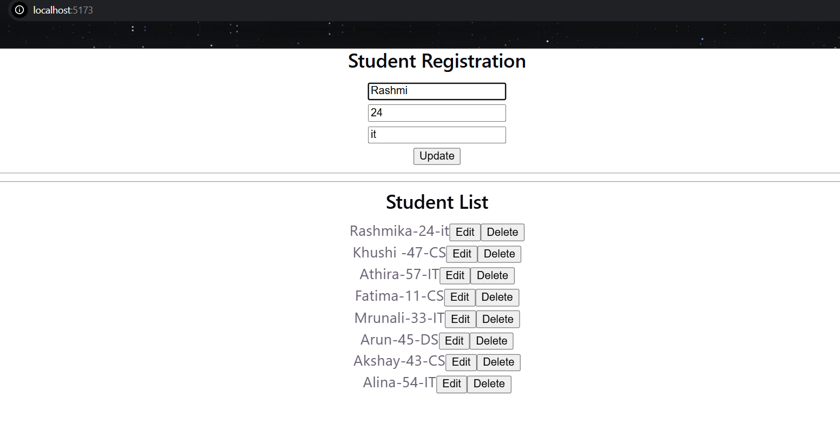
DELETED 3 students details
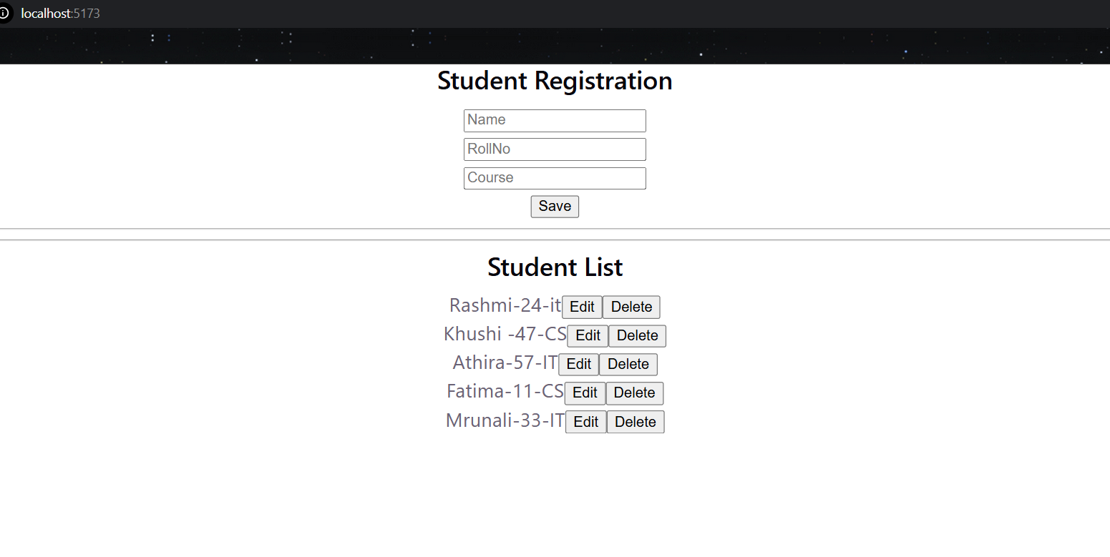
PRACTICAL NO 5
Implement user registration and login functionality using Express.js backend APIs and MongoDB database.(Method 1)
user_login npm init -y npm install express (using array)
│
├── node_modules
├── package.json
└── server.js
Server.js
const express = require("express");
const app = express();
const PORT = 5000;

app.use(express.json());

const users = [];

app.get("/", (req, res) => {
res.send("User Authentication server running");
});

app.post("/register", (req, res) => {
const { Username, Password } = req.body;

if (!Username || !Password) {
return res.status(400).json({
message: "Username and password are required"
});
}

const existingUser = users.find(
user => user.Username === Username
);

if (existingUser) {
return res.status(400).json({
message: "User already exists"
});
}

users.push({
Username: Username,
Password: Password
});

res.status(201).json({
message: "User registered successfully"
});
});

app.post("/login", (req, res) => {
const { Username, Password } = req.body;

const user = users.find(
user => user.Username === Username && user.Password === Password
);

if (!user) {
return res.status(400).json({
message: "Invalid username or password"
});
}

res.json({
message: "Login successful"
});
});

app.listen(PORT, () => {
console.log(`Server running on port ${PORT}`);
});

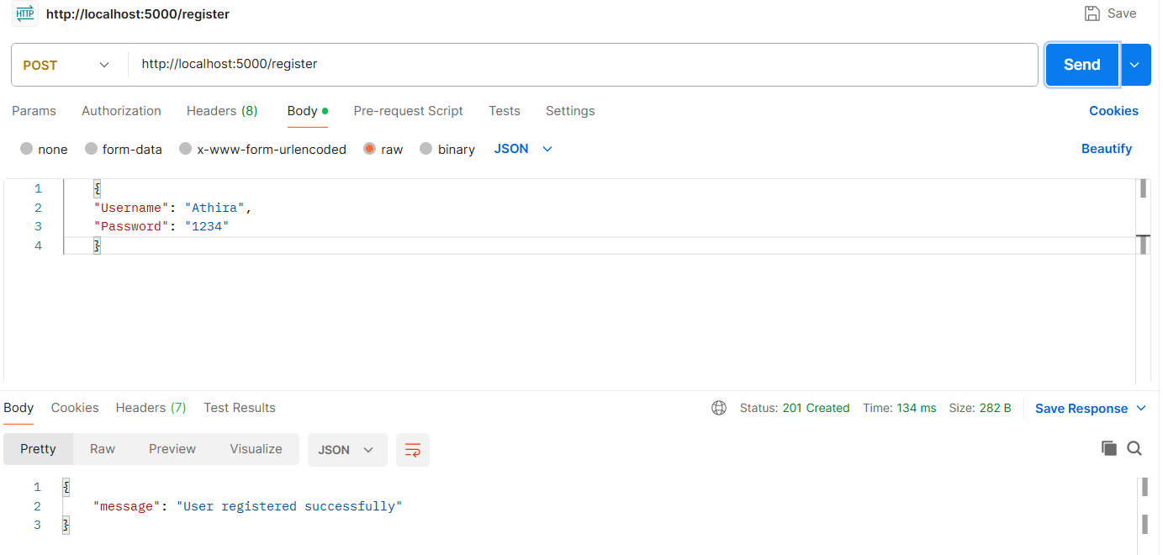
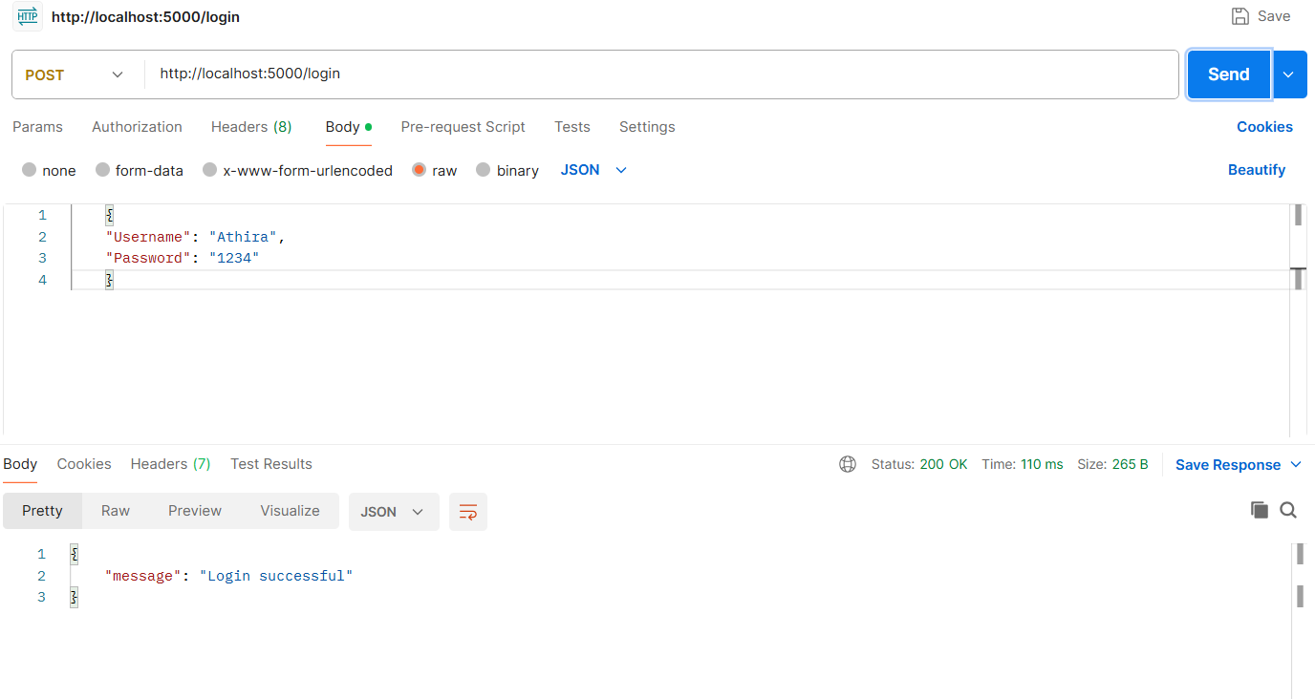
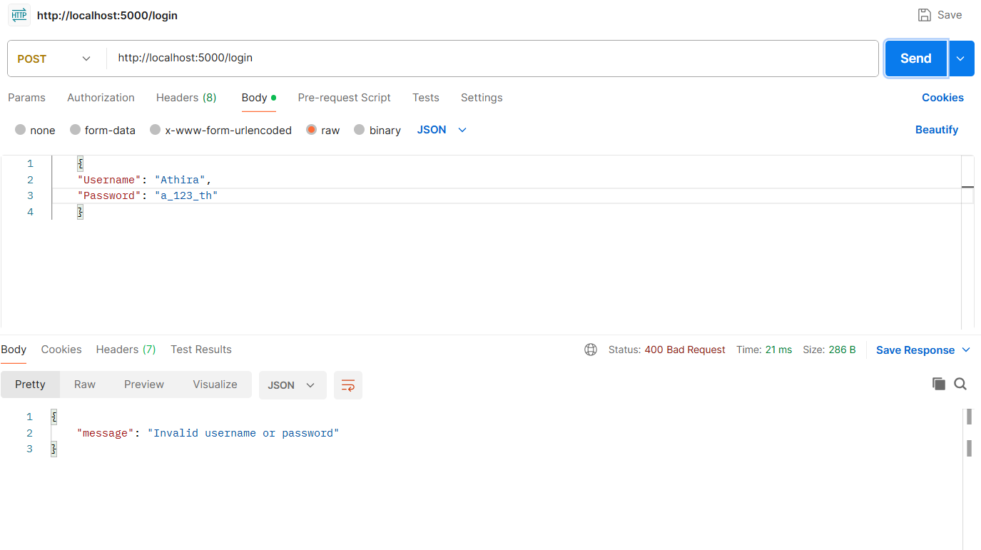

Method 2
Install packages
npm init -y
npm install express mongoose dotenv
.env file
MONGO_URI=mongodb://127.0.0.1:27017/userdb
PORT=3000
Server.js
const express = require("express");
const mongoose = require("mongoose");
require("dotenv").config();

const app = express();

// Middleware to read JSON request bodies
app.use(express.json());

// User Schema
const userSchema = new mongoose.Schema({
username: {
type: String,
required: true,
unique: true
},
password: {
type: String,
required: true
}
});

// User Model
const User = mongoose.model("User", userSchema);
app.get("/", (req, res) => {
res.send("User Authentication API is running");
});
app.post("/register", async (req, res) => {
try {
const { username, password } = req.body;
const existingUser = await User.findOne({ username });
if (existingUser) {
return res.status(400).json({
message: "User already exists" });
}
const user = new User({ username, password });
await user.save();
res.status(201).json({
message: "User registered successfully" });
} catch (error) {
console.error(error);
res.status(500).json({ message: "Server error" });
}
});

app.post("/login", async (req, res) => {
try {
const { username, password } = req.body;
const user = await User.findOne({ username, password });
if (!user) {
return res.status(400).json({
message: "Invalid username or password" });
}

res.status(200).json({
message: "Login successful" });
} catch (error) {
console.error(error);
res.status(500).json({ message: "Server error" });
}
});

mongoose.connect(process.env.MONGO_URI)
.then(() => {
console.log("Connected to MongoDB");
app.listen(process.env.PORT || 3000, () => {
console.log(`Server running on port ${process.env.PORT || 3000}`);
});
})
.catch((error) => {
console.error("Error connecting to MongoDB:", error);
});

